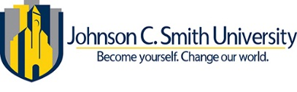
Departmental StafF
Dr. Valerie Kinloch, President
Johnson C. Smith University

Dr. Angela /White, SVP
Strategic Enrollment & Retention Management

Dr. Eric Styles, AVP
Student Affairs, TRIO & Well Being

Magdalyn Lowe-Smith, M.S.,
Director - Upward Bound Program
(704)378-1127

Andrina Forward, M.S.,
Academic Coordinator – Upward Bound
(704) 330-1345

Kimberly M. Harvin, J.D.,
Program Specialist – Upward Bound
(704) 378-1001

The Mission
To provide students with the academic skills and motivation needed to complete high school, enter a four-year college/university, and complete it successfully.
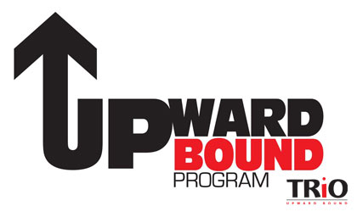

“Destination Transformation: A Blueprint for Change”
Message from the Director
Upward Bound Program
Fall 2025

The Standard
“Are the Children Well?” During Summer Component 2025, Upward Bound staff focused on the well-being of our youth. The question, “Are the Children Well?” is a cultural greeting that prompts one to reflect on the overall health, safety, and flourishing of our youth. We would hope that the response to this question would be, “The Children Are Well!” Statistics show otherwise.

According to the 2023 State of America’s Children Report, “this is a challenging and scary time for America’s children. Millions of them currently suffer from mental health issues, hunger, drug use, homelessness, and hopelessness…”

The fact that our youth are in need academically, socially, and mentally drives the passions of Upward Bound staff, as we assist in the nurturing and caring of our youth. As such, staff developed “Destination Transformation: A Blueprint for Change” for the overall theme of Summer Residential Institute 2025.

This theme was designed to be a program that teaches our students how to manage the current and future trajectory of their lives by applying a five-step blueprint for change. This model took them on a journey from Complacency to Transformation — a journey to wholesome, meaningful, purpose-filled living.

This issue of the “Standard” includes the following: (1) An overview of Summer Component 2025; (2) Bridge Update; (3) UB Academic Honors (2024 - 2025); and much more…Enjoy!!!

Summer Component 2025

The Upward Bound Program
"Creed"

I Am An Upward Bound Scholar!
I adhere to the Upward Bound “Mission

♦ To complete high school
♦ To enter a college or university
♦ To successfully complete the academic
requirements necessary for
college/university graduation.

I Am An Upward Bound Scholar!
I adhere to the Upward Bound “Standards of Conduct”.

♦ I represent Upward Bound and
present myself as a role model in and
out of the classroom.
♦ I stand ready to support and
encourage all Upward Bound
scholars…academically, socially, and
culturally.

I Am An Upward Bound Scholar!
I adhere to the Upward Bound “Standard of Excellence”

♦ I am intelligent, responsible,
disciplined, respectful, strong, and
courageous.
♦ I strive to obtain and maintain high
academic honors.
♦ I maintain a positive attitude at all
times.

I Am An Upward Bound Scholar!

Summer Quick Facts
● Dates: June 15 – July 25, 2025
● Summer Color: Blue, Mauve, White
● Summer Trip: Civil Rights Tour
● Theme: Destination Transformation:
A Blueprint for Change.

Self-Awareness Week
Self-Awareness Week is an opportunity for Upward Bound participants to explore their “Self-Identity” in a positive and supportive environment. Students received two days of vital, in-depth information that incorporated the summer theme and enhanced their future endeavors.
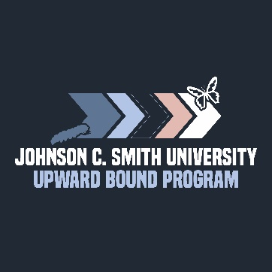
Special thanks to Dr. Eric Styles for welcoming Upward Bound participants to Johnson C. Smith University for their Summer Residential Institute experience. His genuine awareness of the low-income and first-generation population enhanced his message, and his display of hospitality was inviting and heartwarming!
To Our Village Elders…Thank you for taking the time to spend and share a wealth of knowledge with our Children. Blessings extended to you!
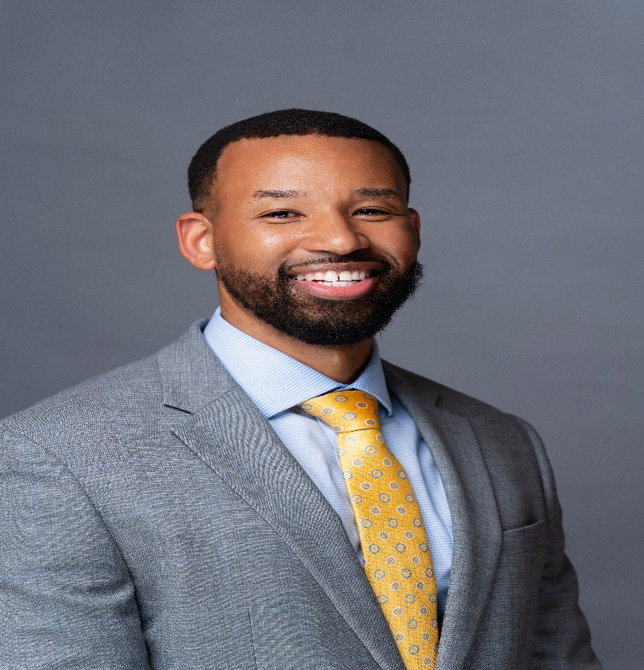

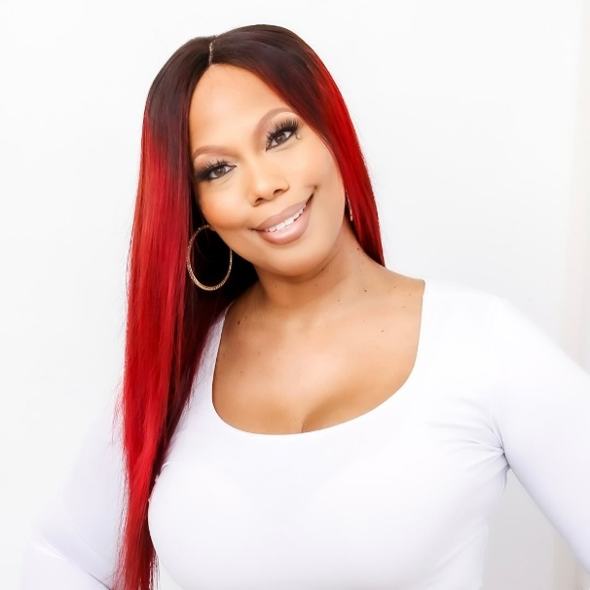
Stephanie Drake Carlisle

Intuitively insightful, passionately invested, and compassionately engaged, Stephanie Drake Carlisle, The Conquer Coach, embodies the quintessential definition of a Change Agent. As a Certified Life Coach and Organizational Culture Consultant, her message resonates with diverse audiences across various settings, including conferences, workshops, coaching sessions, and group settings, through media features, with evidence seen in the results of individuals impacted, groups inspired, leaders ignited, teams motivated, organizations charged, and cultures changed. She is the Founder of Conquer Queen, an initiative focused on promoting the authenticity and empowerment of women through conversations that heal. She is also the Founder of Created to Conquer, a non-profit designed to educate all that “we were Created to Conquer, not to be confined.” Her expertise also reaches the male population and is accomplished through curated content, specially designed curricula, and varying service offerings to include 14 journals, eBooks, Miro-Courses, and more. Her primary goal is to instill in everyone she encounters to LIVE GENUINELY, AUTHENTICALLY, AND UNAPOLOGETICALLY.

Thank you for sharing your story and planting seeds in our lives to help us refocus and realize how fortunate we are to experience the opportunities provided through Upward Bound!

Personal Development Workshop
Opening Speaker/Career Development

Dr. Jason Carthen
Recognized as one of the top executive coaches in the United States, Dr. Carthen, AKA “The Leadership Linebacker,” is a former professional football player with the World Champion New England Patriots. Inducted into the Business & Leadership Hall of Fame, he’s an international speaker, bestselling author, media personality, and philanthropist. With a personal mission to motivate, inspire, and challenge individuals and organizations to achieve their very best, Jason has helped shape over half a million successful leaders. Some of his clients include Warner Bros. Pictures, J.P. Morgan Chase Bank, the U.S. Government, General Motors, Chick-fil-A, FedEx, the National Football League, the Cleveland Clinic, and many more. He is the founder of the I Speak Life Academy and Speak Life University, as well as the nonprofit organization, The Leaders of Tomorrow Initiative, which provides mentoring, training, and educational initiatives for youth and young adults, while being guided by a long-term vision. He has been featured in Harvard Business, Forbes, Christian Leadership, and Inc. Magazine. He earned his Ph.D. in Organizational Leadership from Regent University.

Thank you for inspiring us to do our very best, which will take us to unexpected places in our careers!
The Business of Learning


One of the goals of the Upward Bound Program is to challenge participants academically. This goal was accomplished during Summer Component 2025. Students were required to take classes in the core curriculum (English, Math, Science, and History), Lifelong Learning, and Electives:

Core Curriculum
English (1-4) – Ms. Maxine Hedgepeth
Math (Math I, Math II) – Mr. Malik Richardson
Math (Math III, AFM, Pre-Calculus, and Calculus) – Mr. Michael Owens
Science (Earth & Environmental, Biology, Chemistry) – Ms. Candace Hamlin

Life-Long Learning
Discovery Place (STEM) (9th – 11th Grade)
History (9 - 12 Grade) – Ms. Joann Summerville
College Prep – (12th Grade) – Ms. Andrina Forward

Electives:
Dance – Ms. Janiya Miller
Art – Mrs. Magdalyn Lowe-Smith
Self-Defense – Ms. Jaxine Hendrickson

Discovery Place
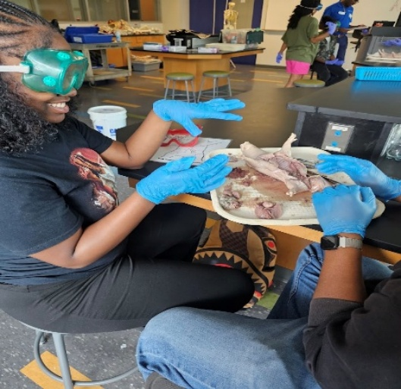
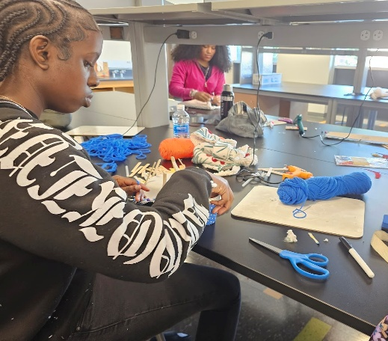
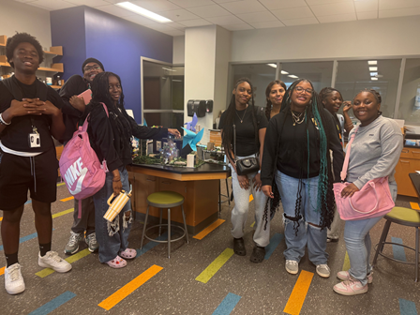
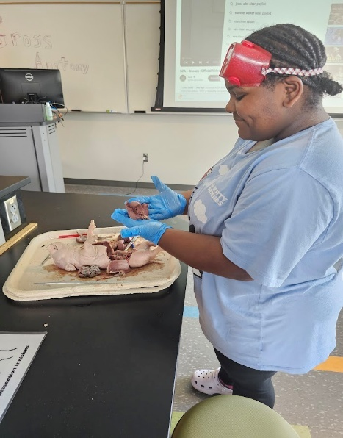
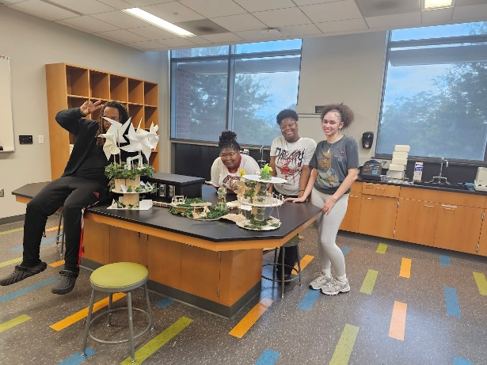
In accordance with our STEM initiative, the Upward Bound Program was privileged to partner with Discovery Place for five (4) weeks during Summer Residential Component 2025.

Discovery Place brings hands-on learning, where the wonders of science, technology, engineering, and math come alive. The program is tailored to specific needs, designed to align with North and South Carolina state standards, as well as the Next Generation Science Standards. The following classes were offered:

Custom Workshop – MAKE - Students stretched their creativity as they explored design thinking within resource limitations.

Custom Workshop – Engineering – By immersing in diverse types of engineering, students experienced how engineering design unfolds through various lenses.

Custom Workshop – Anatomy and Physiology – Through a biomedical science lens, students explored anatomy and physiology, considering how the body systems work together to keep us healthy.

Custom Workshop – Coding/Computer Science – Students explored problem-solving through computer science using a graphics-based programming language.


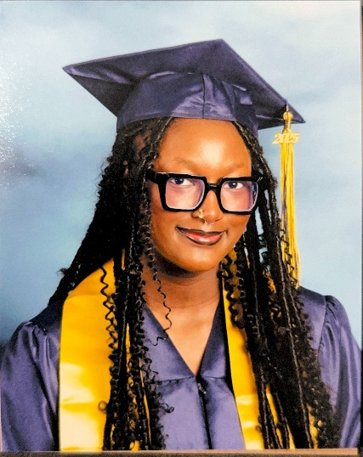

Congratulations!!!
Upward Bound
Class of 2025

Upward Bound Experience Essay Winner
Amari Henderson – North Carolina Central University
(Senior Class Graduate 2025/Bridge Student)

When I first joined Upward Bound, I was introverted and shy. Growing up, I was bullied for my voice (the way it sounded, the way I spoke). Over time, that bullying made me hate my voice, and I would keep my thoughts to myself. I began to hate my voice and, eventually, myself. But Upward Bound changed that. This program didn’t just help me become a better student; it helped me become a better me.

Ms. Lowe, my fearless Director, is the type of person who sees potential in you before you see it in yourself. Her love was tough, but it was exactly what we needed. She pushed us. She reminded us constantly of how much she cared, not just about our grades or performance, but about us as people and our future. When things got hard, she never gave up on us. She always found a way to let you know: You matter, and I’m rooting for you.

Ms. Andi, my UB mom. She let me be my whole self. Whether I was bothering her or coming to her for advice, she’s been like a second mother to me. Her warmth, encouragement, and consistency gave me the space to grow emotionally. She is one of the reasons I came out of my shell.

And speaking of that shell, I’ll never forget the year I got on stage and read my anxiety poem for the first time. My heart was racing, my palms were sweating, and I wanted to run away. But I didn’t. I stood there, in front of everyone, and shared a piece of myself I had always kept hidden. That moment changed everything. That day taught me that being vulnerable is powerful. That my voice matters. That there is beauty in being seen, not just physically, but emotionally. It was the first time I truly removed the mask I had worn for so long. And from that moment on, I started speaking up more, taking risks, and allowing myself to be heard.

Upward Bound didn’t just help me conquer my fear of speaking; it helped me conquer my fear of loving myself. I now love not only my voice, but everything that makes me who I am. I’ve learned that being different is what helps me stand out, and there is strength in embracing your uniqueness.

This program changed my life socially, academically, and emotionally. I walked in as a shy girl, afraid of being seen. I’m walking out as someone who knows her worth, uses her voice, and embraces her full self. And for that, I will forever be thankful.

Congratulations!!!
Upward Bound
Class of 2025 (Continued)

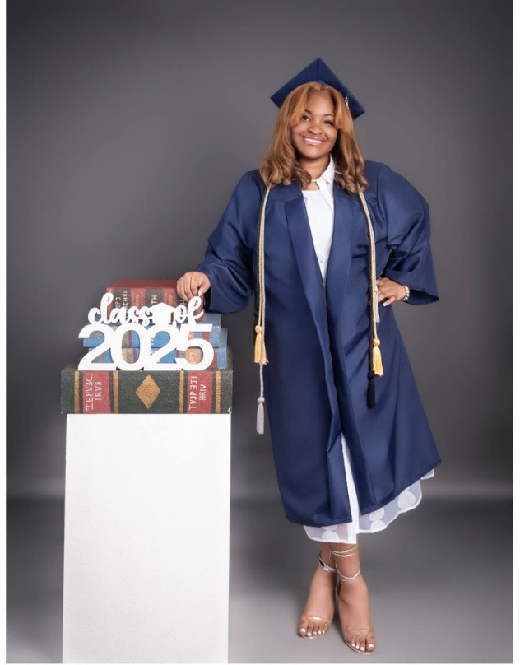
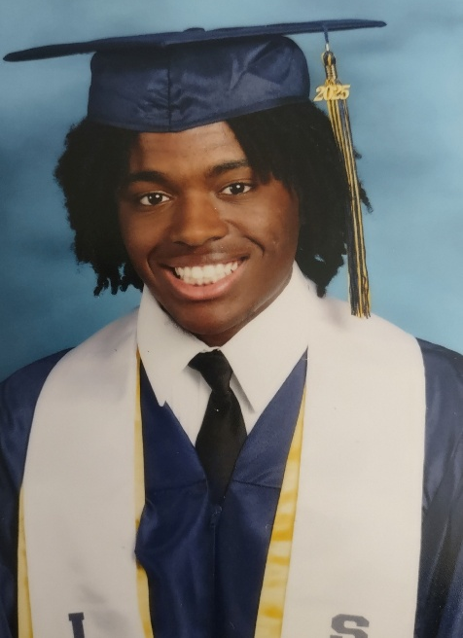
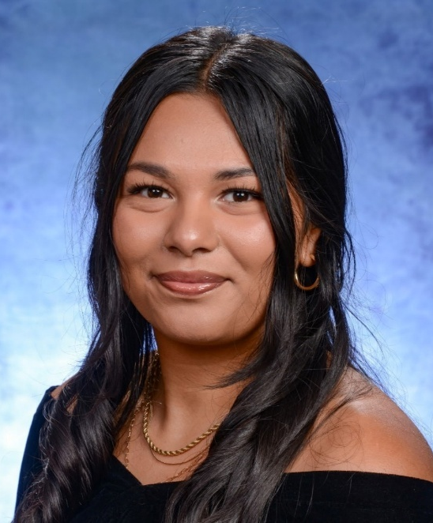

Saniah Brimmer
Winston-Salem State University

Winston Salem State University
Catherine Estrada-Colin
Wingate University

Winston Salem State University
Mason Riley
Fayetteville State University
When I grow older and reflect on my high school years, I know the Upward Bound program will stand out as one of the most impactful parts of my formative journey. Upward Bound has positively influenced my life, preparing me not only academically, but also socially and culturally for the challenges and opportunities of college and beyond.

During college tours, I was not aware of how many options were available to me. This was my taste of real college life, a time when I felt like I was learning about an entirely different culture that I wasn’t familiar with.

Another aspect was the opportunity to stay on campus during the summer. Upward Bound has been more than just a summer commitment or academic support system; it has been a transformative chapter in my life. Every experience has shaped me into a more confident, capable, and driven version of myself.
I heard about Upward Bound through my school. As a first-generation student, I was utterly blind going into the whole college process. However, with the help of Upward Bound, I was able to go through the process with more clarity. We covered all college prep areas, and I was also able to take a college math course, gaining the knowledge and credit I needed to move forward in college.

I have also been impacted socially by this program, transforming from someone who literally sat alone to creating lifelong friendships.

I am very thankful for my time here and the growth I was able to make in so many aspects of my life.

My Upward Bound experience has been outstanding over the years. When I started UB as a rising freshman, I felt lost, I was shy, always to myself, and worried that I didn’t fit in. All the staff members welcomed me, and I began making friends. As the years continued, I saw real growth in myself. I became more confident and less quiet, transitioning from a quiet student to someone willing to speak up and support others.

I can truthfully say that Upward Bound opened my eyes and shaped me into the person that I am today. I now walk with strength, confidence, and purpose. Upward Bound gave me a chance. Thank you for believing in me and helping me find myself.

Congratulations!!!
Upward Bound
Class of 2025 (Continued)

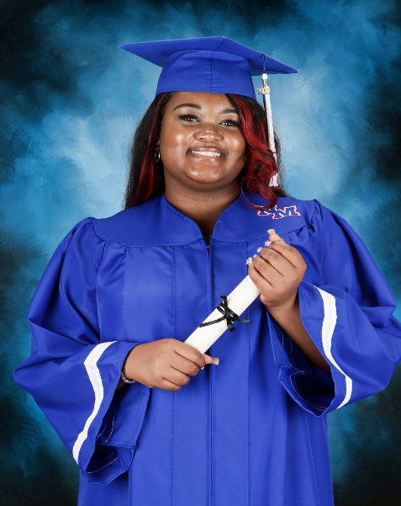
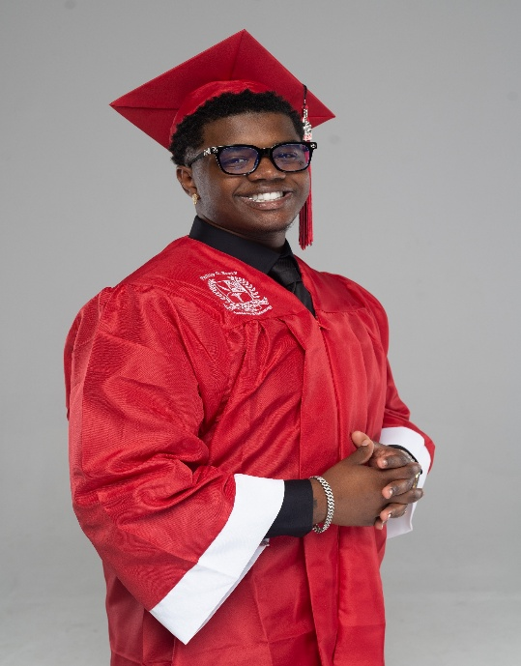

Cameron Young
North Carolina Central University
Miles Walker-Gilliam
Winston Salem State University
My Upward Bound experience has formed me into a smart, socially and academically aware young woman. It challenged me to think critically, manage my time effectively, and deepen my understanding of subjects that are not easy for me to grasp.

UB has provided me with the resources I needed to succeed in high school, including tutors and Saturday classes. Thank you, Ms. Hamlin, for helping me to understand chemistry, and Mr. Owens, for helping me to understand math. Ms. Hedgepeth, thank you! My essays are even better now than they were before. Mr. Richardson, thanks for teaching me how to play chess. And Mrs. Summerville, I thank you for teaching me the importance of keeping up with current events.

A special thanks to Mrs. Lowe-Smith and Ms. Forward. They took a chance and for continuously believing in me. I have become more social and better at communicating. Thank you for the college tours, food, and the ability to visit museums. I am incredibly thankful for this program because I don’t know where I’d be without it.

Being in Upward Bound for four years has truly shaped who I am today. Initially, I was just looking for a way to get ahead in school and prepare for college, but I didn’t realize how much it would affect me academically, socially, and culturally.

Academically, UB pushed me past my limits. The tutoring sessions, summer classes, and college prep workshops showed me that learning doesn’t just happen in the classroom. Socially, UB opened me up to meeting people from different schools and backgrounds. I made friends with individuals who had goals like mine – to be the first in their family to go to college.

Culturally, UB changed my perspective on life. Through college tours and cultural trips, I discovered a world bigger than my city.

Overall, Upward Bound gave me more than academic help. It gave me a family, confidence, cultural awareness, and the mindset to become successful. Without this program, I don’t know where I would be, but with it, I know exactly where I’m going.

Academic Honors & Awards

On Saturday, August 2, 2025, the Upward Bound Program celebrated with an end-of-year Awards Ceremony. Students were given special recognition for their academic honors as well as other categories selected by staff. The following awards were granted for the 2024-2025 program year (June 1, 2024 – May 31, 2025) and Summer Component 2025.

Certificate of Achievement – Academic Year (2024-2025)

3.0 – 3.5

Elias Reynolds, Montreal Mobley, Dre’Onna McDaniel, Jaden Denny, Marlie Dunlap, Myla Council, London Williams, Chase Coe, M’Kaylia Henderson-Freeman, Jayme Fleming, Saniah Brimmer

3.6 – 4.0+

Catherine Estrada-Colin, Kimberly Estrada-Colin, Abigail Estrada-Colin, Nickie Burkett, Scarlett Ramos Pagoada, Serenity Wiah, London Toney, Nari Clinton, Mason Riley, Shaniya Kinard, Ka’Niah Russell, Merite Ushindi, Josiah Welch, Aneiya Ivey, Amari Henderson, Cameron Young, Krista Lasco, Trent Moss, Olga Mundo, Chase Langhorn

Certificate of Achievement – Summer Component 2025

3.0 – 3.5

Serenity Wiah, Jayme Fleming, Ezra Harris, Dakaria Moore, Elias Reynolds, London Toney, Chase Coe, Myla Council, M’Kaylia Henderson-Freeman, Olga Mundo, Don’Tay Bogan, Heaven Hall, Trent Moss, Scarlett Ramos-Pagoada, Josiah Welch, Abigail Estrada-Colin, Nickie Burkett

3.6 – 4.0

Shaniya Kinard, Kimberly Estrada-Colin, Ka’Niah Russell, Merite Ushindi, Nari Clinton, Krista Lasco, Chase Langhorn

Awards Ceremony


Participation Award - Outstanding Attendance – Chase Langhorn

Award of Excellence (Highest GPA) – Academic Year 2024-2025 – Chase Langhorn
Award of Excellence (Highest GPA) – Summer Component 2025 – Chase Langhorn

TC (Tutor Counselors) Choice Award – Olga Mundo, Jacob Mazaba-Kennedy
Newcomer of the Year 2024-2025 – Trent Moss, Serenity Wiah

Bridge Awards
Director’s Award – Mason Riley
Valedictorian Award – Cameron Young
Salutatorian Award – Mason Riley

Annual Summer Cultural/Educational Trip

The Upward Bound Program concluded Summer Component 2025 with a college and Civil Rights Tour (Atlanta/Alabama).
College Tours – Spelman College, Morehouse College, Georgia State University, Alabama State University, Museums/Monuments/Educational Sites – National Center for Civil & Human Rights, “Sweet Auburn Avenue,” Martin Luther King Jr. National Historical Site, Ebenezer Baptist Church/Grave Site, National Visitors Center and Museum, Birmingham Civil Rights Institute, Sixteenth Street Baptist Church, Crossing the Edmund Pettus Bridge, Civil Rights Memorial and Center Equal Justice Initiative, National Memorial for Peace & Justice, IJI Legacy Museum.

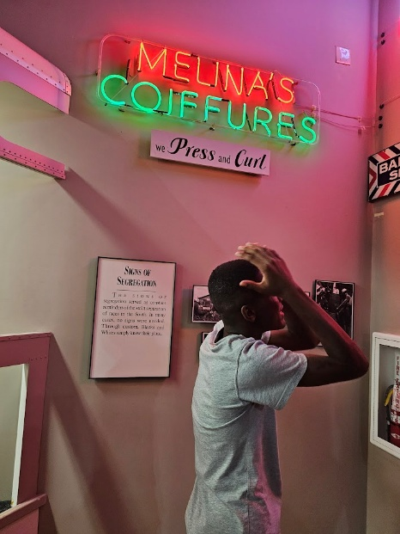
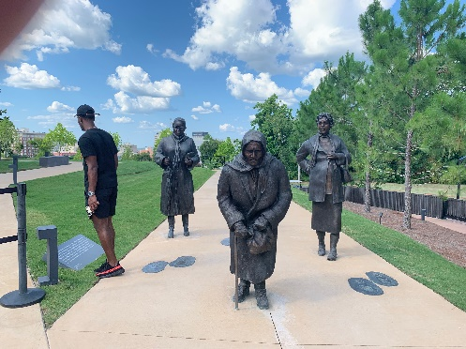
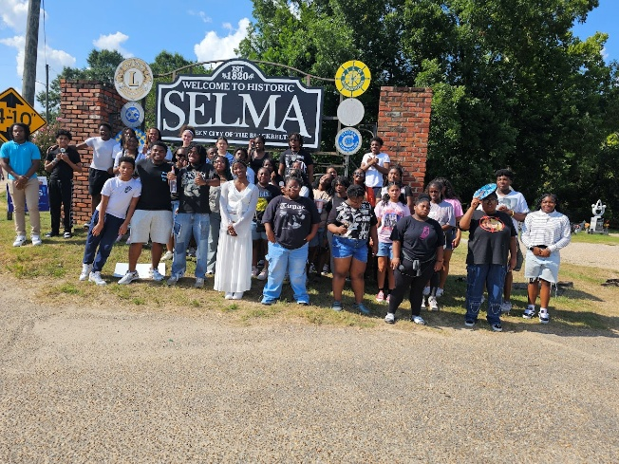
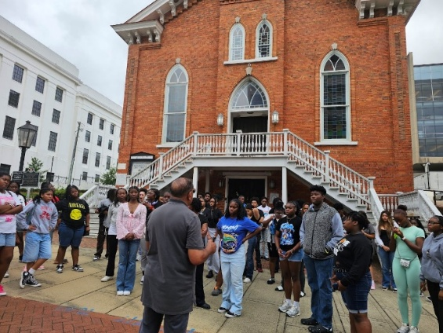
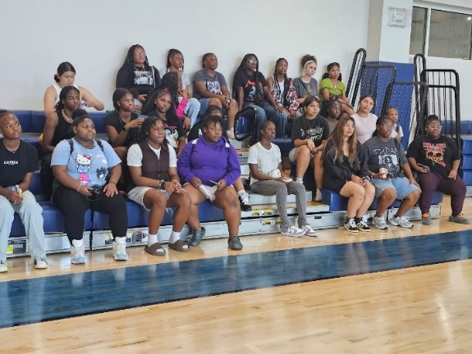
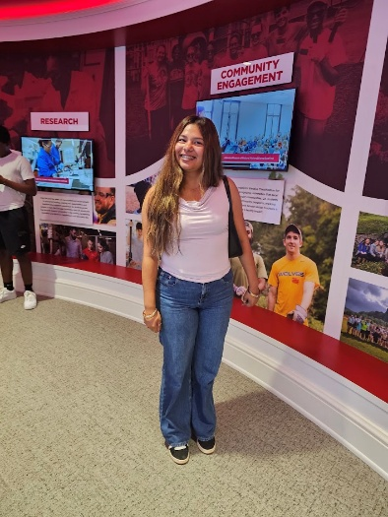
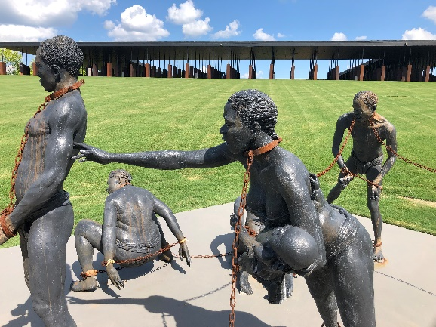
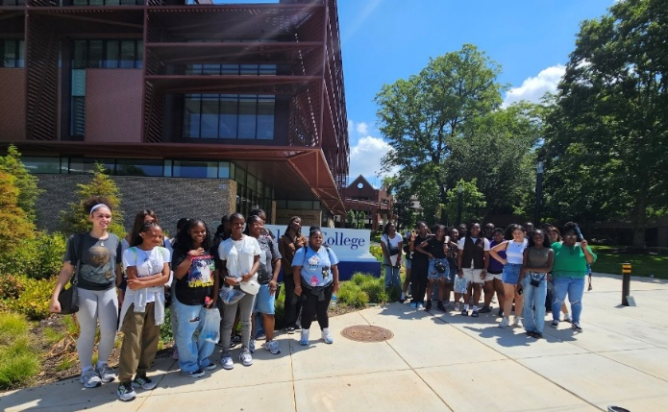



Mental health is a way of describing social and emotional wellbeing. Your child needs good mental health to develop in a healthy way, build strong relationships, adapt to change and deal with life’s challenges. Adolescence can be a risky period for mental health problems. On top of environment and genes, teenagers go through many changes and challenges in a short period of time. This all happens while teenage brains are still maturing. Your love and support and a strong relationship with you can have a direct and positive impact on your child’s mental health. It can even reduce the chances of your child experiencing mental health problems. Here are some ideas to promote your child’s mental health and wellbeing:

- Show love, affection and care for your child.

- Show that you’re interested in what’s happening in your child’s life. Praise their efforts as well as their good points and achievements, and value their ideas.

- Enjoy spending time together one on one with your child, and as a family.

- Encourage your child to talk about feelings with you. It’s important for your child to feel he/she doesn’t have to go through things on his/her own and that you can work together to find solutions to problems.

- Deal with problems as they arise, rather than letting them build up.

- Talk to trusted family members, friends, other parents or teachers if you have any concerns. If you feel you need more help, speak to your doctor or another health professional.

- Physical health is a big part of mental health. To help your child stay emotionally and physically healthy, encourage your child to do the following:
- Keep active. Physical fitness will help your child stay healthy, have more energy, feel confident, manage stress and sleep well.
- Develop and maintain healthy eating habits.
- Get lots of regular sleep. Quality sleep will help your child to manage a busy life, stress and responsibilities.
- Avoid alcohol and other drugs. Alcohol and other drugs are a major risk factor for teenage mental health problems. You should encourage your child to avoid drugs, and don’t give them opportunities to drink alcohol. If you know your child is using alcohol or other drugs and you’re worried, talk with your child. Also, consider speaking to a health professional or counselor.

Information Spotlight
“Teenage Mental Health”

It is normal for children and teenagers to occasionally experience low moods, poor motivation, and trouble sleeping. These things are not always signs of a mental health problem. However, if you notice any of the following signs and they persist for more than a few weeks, it’s essential to talk with your child. The next step is to get professional help. Watch out for if your child is seeming down, feeling like things are hopeless, being tearful or lacking motivation, having trouble coping with everyday activities, showing sudden changes in behavior (often for no apparent reason), having trouble eating or sleeping, dropping in school performance, or suddenly refusing to go to school, avoiding friends or social contact, saying he/she has physical pain – for example, headache, stomach ache or backache, being aggressive or antisocial – for example, missing school, getting into trouble with the police, fighting or stealing, being very anxious about weight or physical appearance, losing weight or failing to gain weight as he/she grows.

If you are concerned about your child’s mental health, start by talking to your child. This might feel uncomfortable – you might even be waiting for the problem to go away. But talking to your child about how they are feeling shows them that they are not alone and that you care. Also, your child might need your help to get professional support. If you raise your concerns with your child, they might refuse any help or say there’s nothing wrong. Many young people won’t seek help themselves. Therefore, you might need to say that you’re worried about them and you’ll be trying to get professional advice. It’s a good idea to encourage your child to come with you. If they won’t, you might need to go on your own. If you’re not sure what to do, a doctor or school counselor is a good place to start. Your child could try a confidential counseling service for young people like Teen Line (teenlineonline.org) -800.852.8336 or Hope Line – (hopeline-nc.org) 877.235.4525.

Mental health problems are unlikely to get better on their own, so you need to get professional help as soon as possible. Poor mental health or unmanaged mental health problems can affect your child’s quality of life, physical health, schoolwork, relationships, and development – social, physical, educational, and vocational. Supporting a child with mental health issues can be hard. It is essential to look after yourself, too. To find support, call Parentline at 1-800-301-300 or visit the Parentline web-counseling page.

https://raisingchildren.net.au/pre-teens/mental-health-physical-health/about-mental-health/teen-mental-health

Awareness Seminar – Personal Responsibility

